**PIZZA SALES SQL QUERIES**

**A. KPI’s**

**1. Total Revenue:**

SELECT ROUND(SUM(total_price),2) AS Total_Revenue FROM pizza_sales;

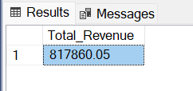

**2.Average Order Value:**

SELECT ROUND((SUM(total_price)/COUNT(DISTINCT (order_id)) ),2) AS Average_Order_Value

FROM pizza_sales

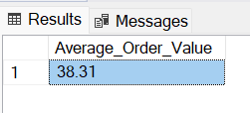

**3.Total Pizzas Sold**

SELECT SUM(quantity) AS Total_Pizza_Sold

FROM pizza_sales

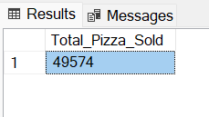

**4. Total Orders**

SELECT COUNT(DISTINCT order_id) AS Total_Order_Placed FROM pizza_sales

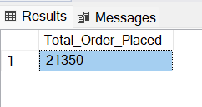

**5. Average Pizzas Per Order**

SELECT CAST(CAST(SUM(quantity) AS DECIMAL(10,2)) /

CAST(COUNT(DISTINCT order_id) AS DECIMAL(10,2)) AS DECIMAL(10,2))

AS Average_pizzas_per_order

FROM pizza_sales

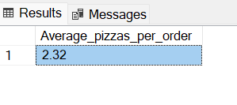

**B. Daily Trend for Total Orders**SELECT DATENAME(DW, order_date) AS Order_Day , COUNT(DISTINCT order_id) AS Total_Orders

FROM pizza_sales

GROUP BY DATENAME(DW, order_date)

***Output:***

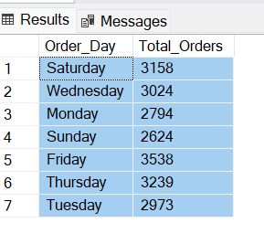

**C. Monthly Trend for Orders**

SELECT DATENAME(MONTH, order_date) AS Order_Month , COUNT(DISTINCT order_id) AS Total_Orders

FROM pizza_sales

GROUP BY DATENAME(MONTH, order_date)

ORDER BY Total_Orders DESC

***Output:***

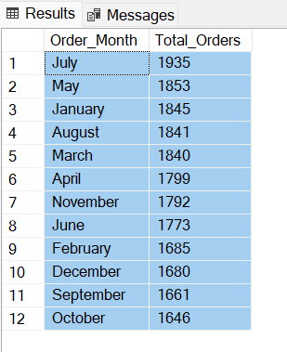

**D. % of Sales by Pizza Category**

SELECT pizza_category,CAST(SUM(total_price)*100/(select sum(total_price) from pizza_sales) AS DECIMAL(10,2)) Percentage_by_Pizza_Category

FROM pizza_sales

GROUP BY pizza_category

***Output:***

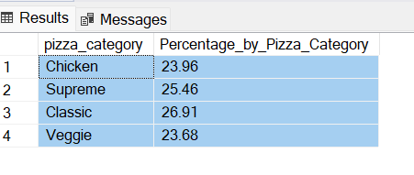

**E. % of Sales by Pizza Size**

SELECT pizza_size , CAST(SUM(total_price)*100 / (SELECT SUM(total_price) FROM pizza_sales) AS DECIMAL(10,2)) AS Percentage_by_pizza_size

FROM pizza_sales

GROUP BY pizza_size

ORDER BY pizza_size

***Output:***

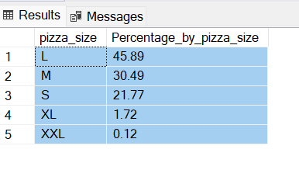

**F. Total Pizzas Sold by Pizza Category**

SELECT pizza_category , SUM(quantity) AS Total_Quantity_Sold

FROM pizza_sales

GROUP BY pizza_category

ORDER BY Total_Quantity_Sold DESC

***Output:***

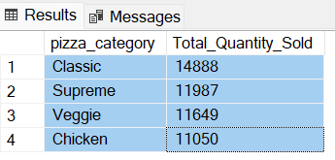

**G. Top 5 Pizzas by Revenue**

SELECT TOP 5 pizza_name , SUM(total_price) AS Top_5_pizza_by_Revenue

FROM pizza_sales

GROUP BY pizza_name

ORDER BY Top_5_pizza_by_Revenue DESC

***Output:***

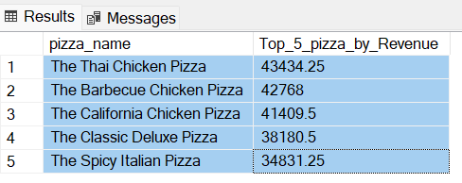

**H. Bottom 5 Pizzas by Revenue**

SELECT TOP 5 pizza_name , SUM(total_price) AS Bottom_5_pizza_by_Revenue

FROM pizza_sales

GROUP BY pizza_name

ORDER BY Bottom_5_pizza_by_Revenue

***Output:***

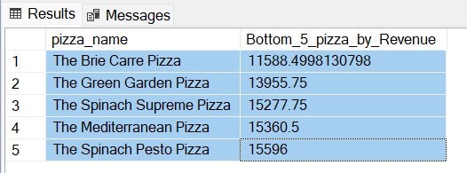

**I. Top 5 Pizzas by Quantity**

SELECT TOP 5 pizza_name , SUM(quantity) AS Top_5_pizza_by_Quantity

FROM pizza_sales

GROUP BY pizza_name

ORDER BY Top_5_pizza_by_Quantity DESC

***Output:***

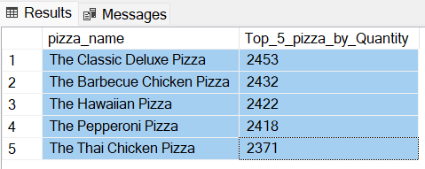

**J. Bottom 5 Pizzas by Quantity**

SELECT TOP 5 pizza_name , SUM(quantity) AS Bottom_5_pizza_by_Quantity

FROM pizza_sales

GROUP BY pizza_name

ORDER BY Bottom_5_pizza_by_Quantity

***Output:***

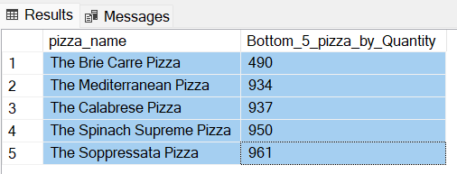

**K. Top 5 Pizzas by Total Orders**

SELECT TOP 5 pizza_name , COUNT(DISTINCT(order_id)) AS Top_5_pizza_by_Orders

FROM pizza_sales

GROUP BY pizza_name

ORDER BY Top_5_pizza_by_Orders DESC

***Output:***

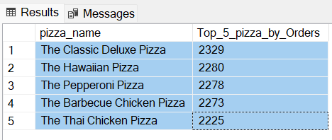

**L. Bottom 5 Pizzas by Total Orders**

SELECT TOP 5 pizza_name , COUNT(DISTINCT(order_id)) AS Bottom_5_pizza_by_Orders

FROM pizza_sales

GROUP BY pizza_name

ORDER BY Bottom_5_pizza_by_Orders

***Output:***

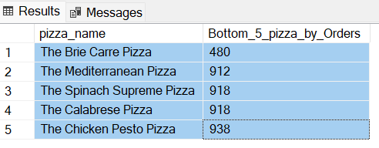

***NOTE***

If you want to apply the pizza_category or pizza_size filters to the above queries you can use WHERE clause. Follow some of below examples

SELECT Top 5 pizza_name, COUNT(DISTINCT order_id) AS Total_Orders

FROM pizza_sales

WHERE pizza_category = 'Classic'

GROUP BY pizza_name

ORDER BY Total_Orders ASC